中華文化青少年夏令營-July 4th, 2001
Editors: Belinda Chiu and Bonita Tseng
Pictures Provided By: Belinda Chiu

七月四日：家人來看小孩
邱瀅真
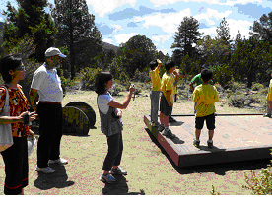
今天是美國的國慶日。因為大部分的家庭會一起慶祝這個日子，南加州中文學校聯合會開放這一天給家人們來看他們的小孩。讓家人們看孩子不僅是為了慶祝國慶日但也是一個機會讓父母和孩子見面。從夏令營的開始，已經兩天過了。有一些父母們為他的孩子擔心，也有小孩子們在想念爸爸媽媽。在這一天，家人們有跟他們的孩子吃飯，看孩子的宿舍，和跟孩子去他的活動。希望各位家長們在這個時間有跟孩子問好和看看孩子的環境。以下有一些照片。
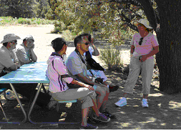

Archery
By Bonita Tseng

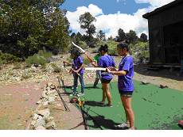
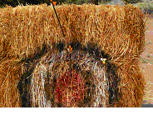
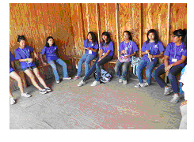
As the kids walked towards the archery range, they couldn’t help but stare wide-eyed at the haystacks and the bows and arrows. After listening to the instructions, the kids immediately began to jump up and down and screaming that they wanted to go first. Each student pulled the arrows back before they shot and studied the targets carefully and after aiming, they all began to fire. Many of them did well, almost all of them had at least a few arrows hitting towards the center. Everybody wanted to go again and again, but in order to be fair, they would take turns and go in rounds of three. The counselor as well as I would also switch off because there was one bow on the range that was made especially for adults. After shooting, everybody would wait until everybody was done and then they would go out to get their arrows. However, while collecting the arrows, everybody had to keep in mind that there were eight arrows and they would have to keep their arrows behind their backs. This was so that in case they fell, they would be able to stop themselves with their hands instead of getting stabbed by the arrows. The kids wanted to go again and again, but they were so excited. They kept wanting to shoot the bull’s eye, but it was very difficult. Only the counselor, Daniel, was able to shoot the bull’s eye on the first try. Many of them were very close to hitting it as well. However, if there was a bad round, they would mostly blame the bow. Pulling back the string was the hardest part because it was very taut. A couple of times, the string would rebound and brush my cheek. Each kid thoroughly enjoyed this activity even though there were a lot of safety rules and regulations and even with all of the required actions such as standing sideways with your hips facing the targets, using only the index and middle fingers to pull the string back and to aim very carefully so that nobody would end up getting hurt at all.
High Ropes
By Bonita Tseng
When I went with the green group to the high ropes course there were only three actions to take the Leap of Faith was the best because you had to be able to trust whoever it is that was belaying you to catch you. If you had to get up the ladder, the most part was that the most of the people would keep on encouraging each other and then once the things were done then they would switch helmets. Everybody wanted to go on all three, but they were unable to because of the time limits. However, everybody enjoyed the challenges of climbing up and jumping or climbing up and completing the course.

Chinese Yo-Yo
By Bonita Tseng
Everybody loves to see people playing Chinese yo-yo because it is so much more fancy and complicated than other types of sports and as well as American yo-yos. The teacher was very excellent. He would teach them to first start up the Chinese yo-yo and then after starting it up he would teach them a few complicated tricks and some of them would seem like magic. The first one that I learned was the one where through a series of oops and twists and turns, if you pulled out the yo-yo, you would be able to pull it through without anything getting caught.

Group Practices
By Belinda Chiu
It's that time of the camp again! A SCCCS youth camp tradition of group performances is in the process. Today is the second day of preparations for each of the groups. As I was on the scene, I saw a couple of the groups preparing many different shows. Although more practice is needed, the progress and effort is evident. There's a mixture of comedy, drama, action, and art from what I have seen today. The younger kids sure do have the cuteness level while the older students are portraying a more complex and sophisticated act. Hard work is seen on both sides- the counselors and the students. The counselors are making sure the students pay attention and the performances perfect while the students are trying their best to give a great performance. Of course, with all the practicing, there is also break time! It seems like all the students have gotten along well with each other and can naturally hold conversations. That's a lot of progress for three days! However, final performance is coming soon. Even with all the activities and break time, I'm sure the groups will be able to complete their show. Unfortunately, I will not mention too much about each performance since that will just spoil it. :P So, I'll leave the contents of the performances as a mystery until the day you actually see it! (For those not at camp, hopefully your kid has videotaped it and will show it to you!) Hope you guys all anticipate the final show! Also, good luck to those who are participating! Give out your best shot!

